224G1A0540 Lakshmi Abheegna 07-12-2023

# EXPERIMENT-15

AIM : TO Write PL/SQL program to implement Trigger on table.

Trigger is invoked by Oracle engine automatically whenever a specified event occurs.Trigger is stored into database and invoked repeatedly, when specific condition match. Triggers are

stored programs, which are automatically executed or fired when some event occurs. Triggers are written to be executed in response to any of the following events.

A database manipulation (DML) statement (DELETE, INSERT, or UPDATE).

A database definition (DDL) statement (CREATE, ALTER, or DROP).

A database operation (SERVERERROR, LOGON, LOGOFF, STARTUP, or SHUTDOWN).

CREATING A TABLE AND INSERTING VALUES INTO TABLE :

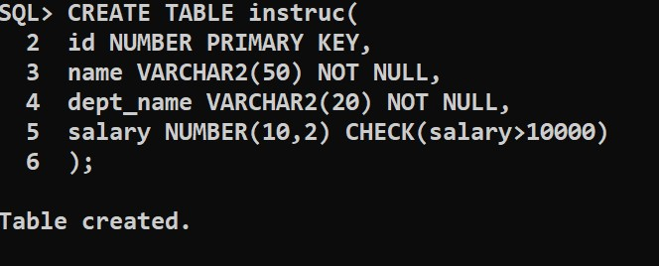

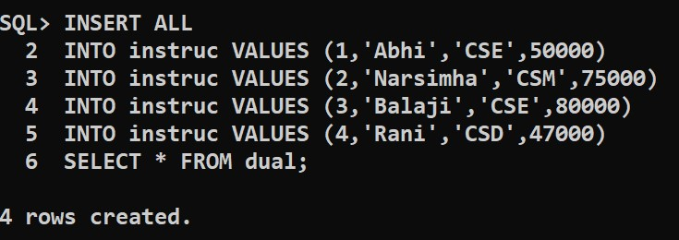

224G1A0527 HARSHITHA 07-12-2023

**An example to create Trigger :**

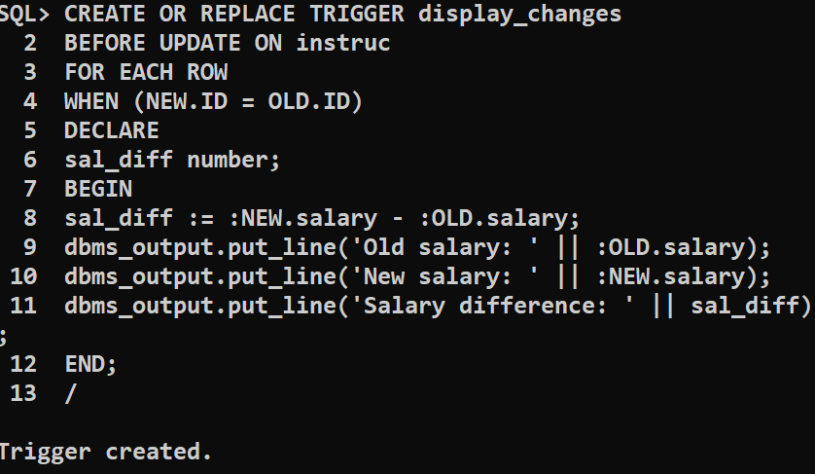

**A PL/SQL Procedure to execute a trigger:**

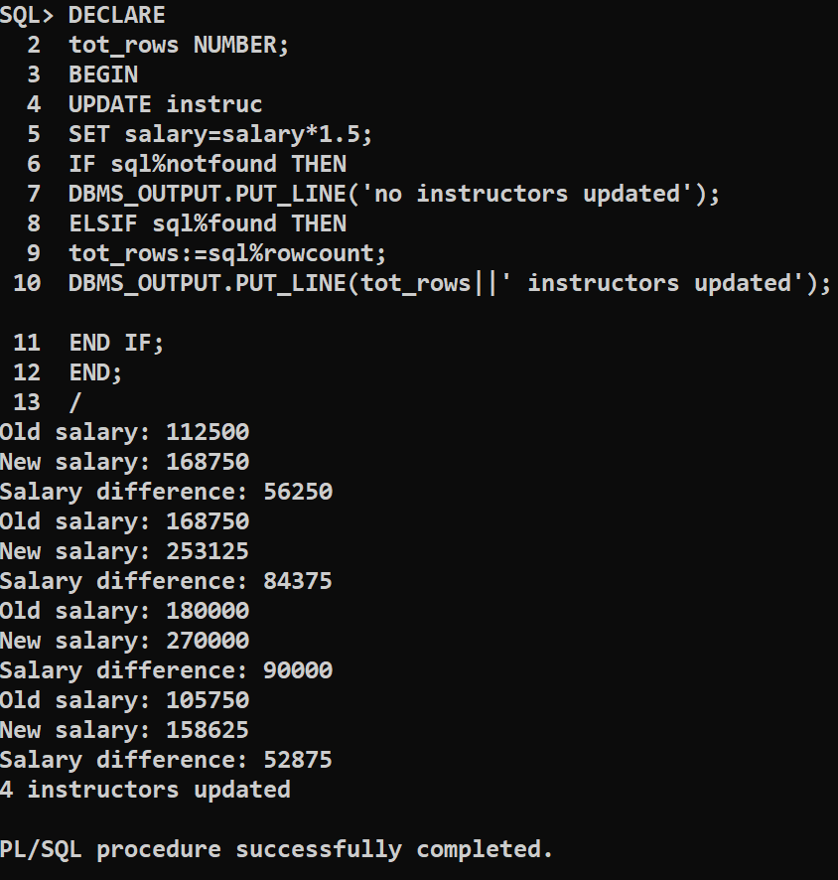

CONCLUSION : PL/SQL program to implement Trigger on table is successfully executed.